Guide for Controlled Substance Registration Certificate Application for an EMS Agency
INITIAL APPLICATION

Before applying for a Controlled Substance Registration Certificate (CSR), ensure you review the following documents. It is mandatory to obtain a CSR before storing any drugs outside of an ambulance. Additionally, the DEA generally prefers for the state CSR to be issued prior to issuance of a DEA registration.
- Controlled Substances Registration Inspection Report
- Virginia Board of Pharmacy Emergency Medical Services Drug Kits
- 18VAC110-20-710

Step 1
Visit https://www.dhp.virginia.gov/Forms/ for the “Forms and Applications” for the Department of Health Professions.
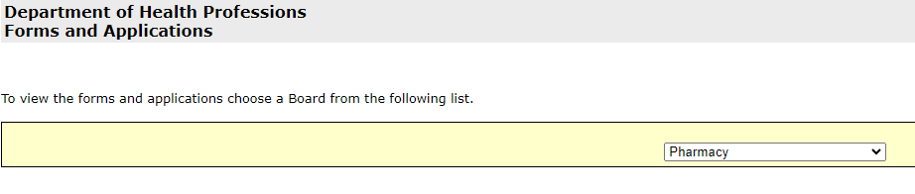
Step 2
From “Forms”, click on the dropdown menu and select “Controlled Substances Registration”.
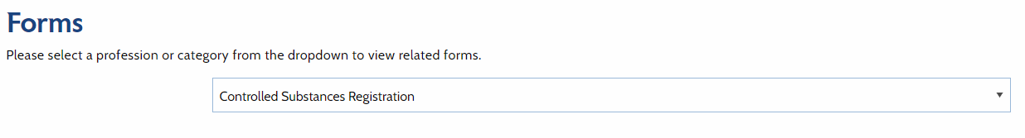
Step 3
Right-click on the link for “Application for a Controlled Substances Registration for Various Entities” and then click “Save link as…”. 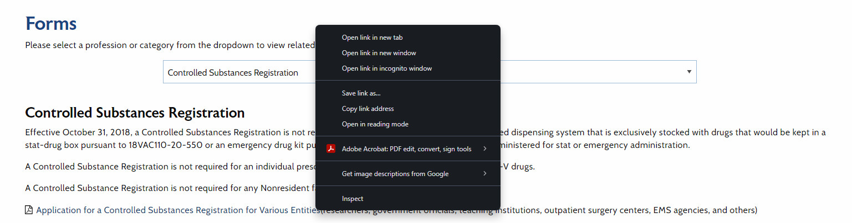

Step 4
Open the PDF and complete it. Further information is provided for each section below.
- Check the “New” box
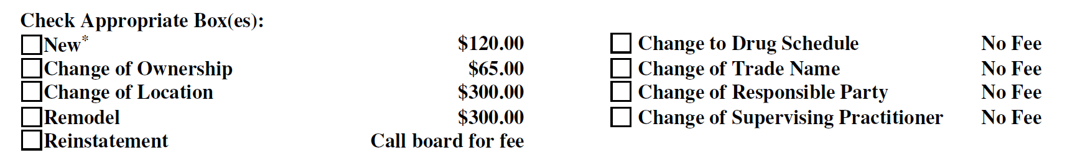

Notes:
- Application fees are not refundable.
- Applications are valid for one year from the date of receipt.
- The required fees must accompany the application.
- Make check payable to “Treasurer of Virginia”.

- “Type of Activity” mark the box for “EMS Agency”
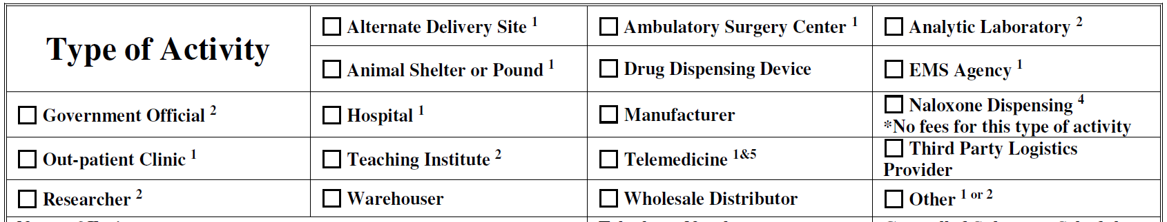
Notes:
- See “Footnotes” on the last page of the CSR Application. Agencies will need to submit a description of the processes/business practices for which this registration is being sought.
  - Questions and examples are provided along with a template for writing the needed letter and can be found within this guide.
  - You are required to submit the letter with your application for a CSR. However, you are NOT required to use the template to write your letter
- If you plan to store regional drug kits outside of the locked compartment of a licensed unit you will need a CSR.
- Some agencies have a single CSR but have multiple stations. This is because their regional drug kit storage and/or backstock are limited to the one location where their CSR is issued.
- Regional Drug Kits that are not secured on a unit in a locked temperature-regulated compartment MUST be secured at a location with a CSR.
- Agencies that have additional supplies of drugs outside of the regional drug kit MUST have a CSR.
- If you plan to store regional drug kits or have backstock at multiple locations/stations, then you will need to obtain a CSR at each location.
- A CSR is only good for the location for which it was issued and IS NOT a blanket certification for an agency and all its stations.
- NOTE: An inspection of the drug storage location within the building will be performed prior to the issuance of the CSR. If your agency is storing drugs prior to having a CSR, your agency may be cited for a deficiency. No drugs may be ordered or stored in the building for this purpose prior to the issuance of both the CSR and DEA.

- Agency Information and Drug Schedules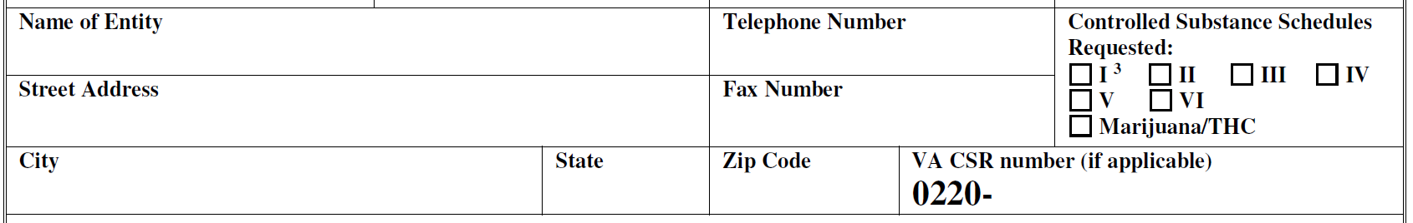

Enter your agency’s information.
  - Address: This should be for the location where drugs will be stored. Do not provide a PO Box.
  - Controlled Substance Schedules Requested: EMS agencies utilize Controlled Substance Schedules II – VI.
    - DO NOT mark Schedule “I” or “Marijuana/THC”.
  - VA CSR number: You should leave this blank since this is for an initial application.

- Responsible Party Information:
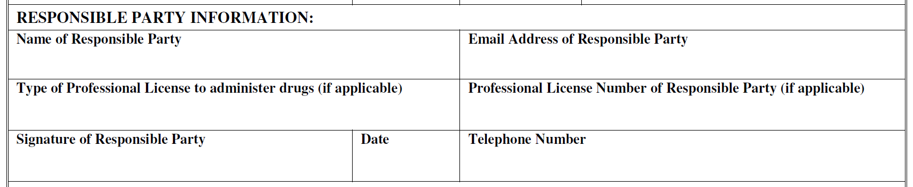
  - Name of Responsible Party: Legal name of the Responsible Party (RP)
  - Type of Professional License to administer drugs (if applicable): This is where you should provide the RPs certification level. i.e Paramedic, Intermediate, AEMT, or EMT.
  - Professional License Number of Responsible Party: This is the RP’s Virginia Office of EMS Certification Number.
  - Notes:
    - The Responsible Party MUST be able to administer ALL drugs that are to be stored.
      - ALS agencies should have a responsible party who is an ALS provider and can administer every stored medication.
      - A BLS provider can be the responsible party, but the medications stored will be limited to their scope of practice even if there are practicing ALS providers at the agency.
    - The Responsible party can be your Operational Medical Director (OMD); however, the responsible party MUST “work .
    - Within 14 days of a change in the responsible party assigned to the registration, either the responsible party or outgoing responsible party shall inform the board and a new application shall be submitted indicating the name and license number, if applicable, of the new responsible party.

- Supervising Practitioner Information:
  - Each agency MUST have a supervising practitioner listed for their CSR.
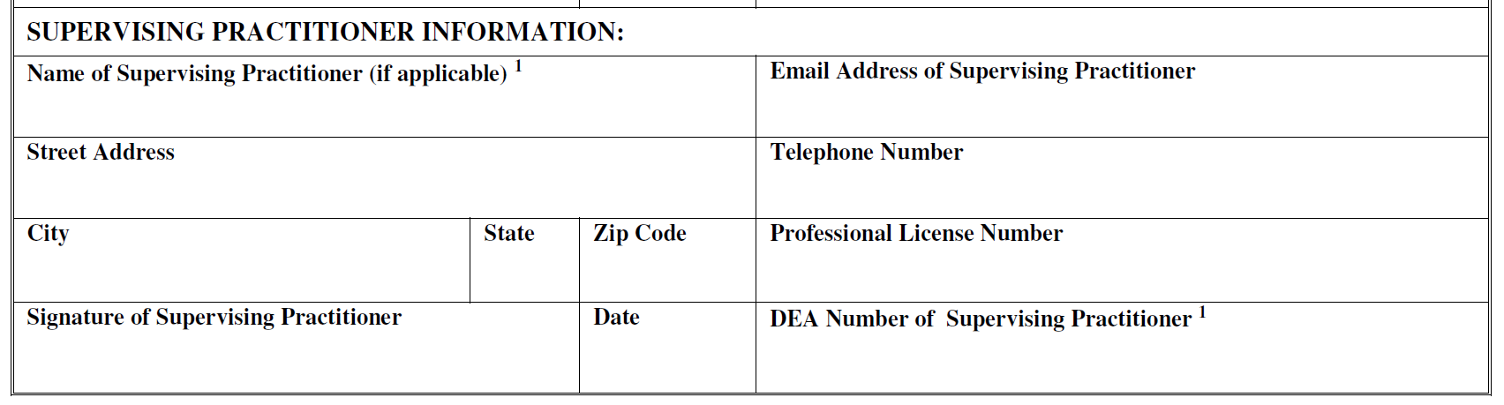
  - Name of Supervising Practitioner: Legal name of your OMD
  - Street Address: Your OMD’s Address.
  - Professional License Number: Your OMD’s license number.
  - DEA Number of Supervising Practitioner: Your OMD’s DEA number
  - Notes:
    - Within 14 days of a change in the supervising practitioner assigned to the registration, the responsible party shall inform the board and a new application shall be submitted indicating the name and license number, if applicable, of the supervising practitioner.
    - A practitioner licensed in Virginia shall provide supervision for all aspects of practice related to the maintenance and use of controlled substances as follows:
      - In an emergency medical services agency, the operational medical director shall supervise.

- Inspection Information:
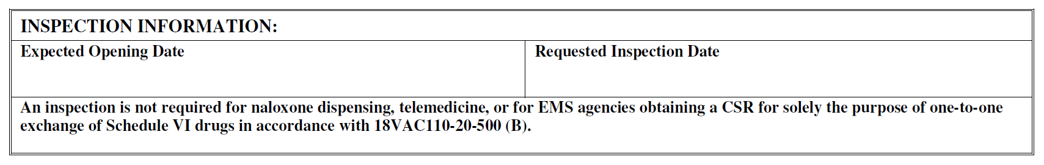
  - Expected Opening Date: This should be the date you plan on storing medications at the listed address on the application.
  - Requested Inspection Date: This is the date that you would like an inspector to come out to inspect the site before the expected opening date.
    - Please ensure that your inspection date is be prior to your expected opening date.
    - NO drugs should be stored onsite until after your inspection, and your agency has received the CSR. If drugs are found on-site, you may be cited for a deficiency.
  - Notes:
    - Please review the Controlled Substances Registration Inspection Report pages 2-4 (link below) prior to submitting an application for a Controlled Substance Registration Certificate.
    - https://www.dhp.virginia.gov/media/dhpweb/docs/pharmacy/forms/Inspection/CSRInspectionReport.pdf
      - Review this document to ensure that you are aware of all items that the inspector will be looking at when completing a site inspection.
    - Please be advised that a 14-day notice is required to schedule an inspection. Prior to the requested inspection date, an inspector will contact the responsible party to confirm readiness. Should the inspector fail to confirm the date, the responsible party is encouraged to reach out to the DHP Enforcement Division at (804) 367-4691 to verify the inspection date directly with the inspector.
    - Note: Due to a high volume of requests from EMS agencies across the state, the Department of Health Professions may not schedule the actual inspection within 14 days of the application date. Your inspection may be scheduled several weeks after applying. Although inspectors have 14 days to schedule an inspection, this does not guarantee an on-site visit within that period. Prompt responses to requests for additional information are crucial, as delays in providing this information can significantly postpone your inspection date. Be aware that applications are valid for one year only.

- Ownership Type:
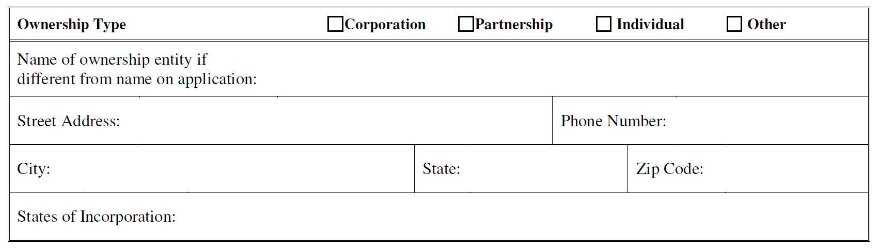
  - Ownership Type: Select the agency ownership type.
    - For “Other” you should specify the ownership type in the description of the processes/business practices letter that will be submitted with your application.
  - Name of ownership entity if different from the name on the application: This is for agencies that are currently “Doing Business As” (DBA) another entity.
    - You should provide details about this in the description of the processes/business practices letter if applicable.
  - Street Address: This is the business mailing address for the agency.
  - States of Incorporation: If your agency is incorporated in other states, you should list the states in this box.
    - You should provide details about this in the description of the processes/business practices letter if applicable.

- Other Trade or Business Names
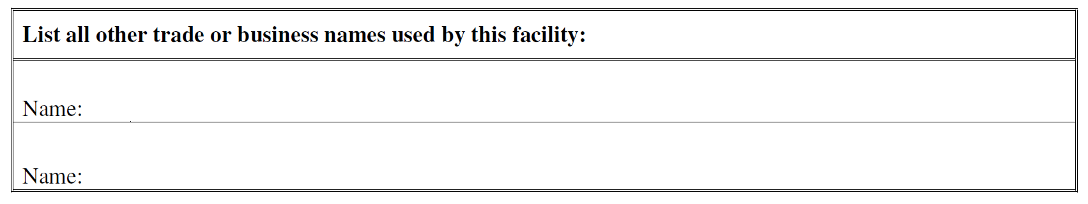
  - Provide all other trade or business names for your agency.
Example: “Town Volunteer Rescue” operates under “Big County Fire & EMS” but has maintained its agency name and organization structure, including their OMD, but is just operating under the county EMS license but needs a CSR. You would want to put that whichever agency is not listed as the “Name of Entity” here.
    - You should provide details about this in the description of the processes/business practices letter.

- Owners/Officers Listing 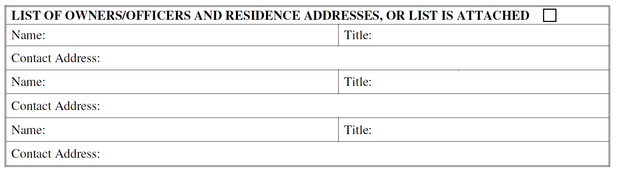
  - This should be the top three officers/owners for your agency.
    - Examples: President, Vice President, Chief, Deputy
  - You may enter “See Attached Listing” to complete this section and provide an attached listing of three or more owners/officers. Be sure to include, at minimum, each person's name, title, and contact address.
    - It is highly recommended that the contact address not be the mailing address for the facility/station.

Description of Process/Business Practices Letter Guide & Template

Description of the Processes/Business Practices Letter (REQUIRED)
  - When submitting your initial application, it is imperative to include a Description of the Processes/Business Practices.
  - In the subsequent pages, you will find a set of questions and example answers designed to assist you in creating your letter. By completing these questions and utilizing them as a basis for your letter, you will be ahead of the curve.
  - You are NOT required to use this guide and template as it is only provided as a tool to assist you. If you feel confident writing your own letter please do so.
  - This document serves as guidance to aid you in completing the necessary submission alongside your CSR application. It does not encompass all aspects and is not intended to substitute your agency's internal review of processes to ensure compliance with agency, local, state, and/or federal requirements, regulations, and laws.
  - It is highly recommended that this document be printed and submitted on your agency's letterhead to the Board of Pharmacy.
  - It is highly recommended that you consult the following resources both before and during the composition of the Description of the Processes/Business Practices:
    - Controlled Substances Registration Inspection Report:
      - https://www.dhp.virginia.gov/media/dhpweb/docs/pharmacy/forms/Inspection/CSRInspectionReport.pdf
    - Virginia Board of Pharmacy Emergency Medical Services Drug Kits:
      - https://www.dhp.virginia.gov/media/dhpweb/docs/pharmacy/guidance/110-41.pdf

Letter Template
Please refer to the business letter template on the following page to assist in composing your letter to the Board of Pharmacy.

Questions and example answers are provided on subsequent pages to facilitate the creation of a clear and concise letter. This guidance is designed to help you quickly complete your letter, ensuring timely processing of your CSR application without any delays from additional inquiries.
Once you have all sections completed you can copy and paste your answers into the provided format to have a complete letter.

Printing the first page of your letter on letterhead and signing it on the last page is highly recommended. If your agency lacks letterhead, please include your agency’s name, street address, city, state, and zip code above the letter date.

Please remember to enclose a check for the specified amount, signed and made payable to the "Treasurer of Virginia", with your application and letter.


[Agency Name] ABC Agency, Inc.
If your letterhead has your agency mailing address, you may omit this portion.
EMERGENCY
[Street Address] 123 Rescue Rd
[City, State Zip] Somewhere, VA 23456

[Date] Friday, May 1, 2024

ATTN: Board of Pharmacy
Department of Health Professions
Perimeter Center
9960 Mayland Drive, Suite 300
Henrico, Virginia 23233-1463

Dear Board of Pharmacy:

[Description of Process/Business Practices using Section 1]

[Purpose of Registration Paragraph using Section 2]

[Supervising Practitioner Paragraph using Section 3]

Storage:
[Questions 4.1 – 4.5]

Distribution/Dispensing:
[Questions 4.6 & 4.7]

Security:
[Questions 4.8 – 4.10]

Records:
[Questions 4.11 – 4.16]

Responsible Party:
[Questions 4.17 & 4.18]

[AGENCY NAME] encourages open dialogue and invites any inquiries, corrections, recommendations, or guidance from the Board of Pharmacy or Department of Health Professions inspectors. We eagerly anticipate collaborating with you all and express our gratitude for your time and attention to this matter.

Sincerely,
Leave 4 lines.
[Name], [Cert]
[Title]
[Phone]
[Email]

Enclosures: CSR application form, check for application fee

Section 1: Description of Process/Business Practices
1.1 Provide a detailed description of your agency, including the nature of the service(s) provided, such as volunteer, private, corporate, or governmental, the locality it serves, and the services it offers, such as 911 response and transport and/or interfacility transport.
- Example: I am writing on behalf of [AGENCY NAME], which is a [volunteer/career] EMS agency serving the [City/County] of [LOCALITY], providing [911 response and/or interfacility] transport of sick and injured persons to various destinations.
- Your response:

1.2 What are the certifications of the staff members in your agency, such as Emergency Medical Technician, Advanced EMT, Intermediate, Paramedic, etc.?
- Example: Our team is comprised of certified Emergency Medical Technicians (EMT), Advanced EMTs (AEMT), Intermediates, and Paramedics. As part of our mission, we may encounter situations where the administration of controlled substances is necessary to ensure the well-being of our patients.
- Your response:

Section 2: Purpose of Registration
2.1 What is the primary goal of your agency seeking controlled substance registration (CSR)? Explain why your agency needs a controlled substance registration, considering its role in emergency medical services.
- Example: [AGENCY NAME] is seeking a controlled substance registration (CSR) to facilitate the safe and lawful maintenance, distribution, and use of controlled substances within our emergency medical services agency. Our goal is to ensure that controlled substances are handled, stored, and administered with the utmost care, adhering to all relevant regulations and guidelines. Our comprehensive approach to emergency medical services encompasses a range of scenarios, from acute medical emergencies to situations requiring specialized care during transit, which may include the administration of Schedule II through VI drugs.
- Your response:

2.2 Is your agency planning to utilize the ODEMSA Regional Drug Kit Program, and if so, how will it be incorporated into its controlled substance practices?
- Example: [AGENCY NAME] plans to utilize the [Regional Council Name(s)] Regional Drug Kit Program for the foreseeable future, which at this time contains schedule II through VI drugs. We will be purchasing, stocking, and storing additional drugs outside of the standard Regional Drug Kit Program but do not intend to include Schedule II drugs outside of the Regional Drug Kit.
- Your response:

2.3 Will your agency be storing additional drugs outside of those included in the ODEMSA kit, and if yes, which drugs?
- Example: Besides the drugs included in the Council Regional Drug Kit, [AGENCY NAME] intends to stock the following drug: [list of specific drugs]. These drugs will enhance our ability to provide comprehensive emergency medical care and possibly decrease unit turnaround times at hospitals, as there will not be a need to wait for hospital pharmacies to provide assistance as they do with the Regional Drug Kit.
- Your response:

2.4 If your agency has more than one station, how will it manage CSR for each station? Will there be a central location for storage? If your agency only has one station, you should state that here.
- Example:[AGENCY NAME] has [3] stations across [LOCALITY]. At this time, we will be storing all drugs from a central location within [LOCALITY]. Storage will be at [ADDRESS] and is anticipated to be designated for controlled substance storage to ensure uniformity and compliance across all stations. Should the need arise to remove drugs from the truck for any reason outside of patient care, drugs will be stored at this location.
- Your response:

Section 3: Supervising Practitioner
3.1 Who is the designated supervising practitioner for your agency, and what role will they play in overseeing controlled substance practices?
- Example: The designated supervising practitioner for [AGENCY NAME] is Dr. [Supervising Practitioner Name], who will oversee all aspects of practice related to the maintenance, distribution, and use of controlled substances. Dr. [Supervising Practitioner Name] will be working with our agency to establish procedures and will provide or designate others to provide any necessary training to ensure compliance with all legal and regulatory requirements.
- Your response:

3.2 What procedures will the supervising practitioner establish, and how will they provide necessary training to ensure compliance with legal and regulatory requirements?
- Example: Dr. [Supervising Practitioner Name] will establish comprehensive procedures, including regular training sessions, to ensure that [AGENCY NAME] adheres to legal and regulatory requirements in handling controlled substances.
- Your response:

Section 4: Key Processes and Business Practices

Storage:
4.1 Where and how will controlled substances be stored? Please provide details on the type of locks used and access restrictions.
- Example: Controlled substances will be stored in cabinets with combination locks on each, secured in a climate-controlled supply room using an electronic access control system with an electronic lock. Schedule II drugs will be securely stored in a combination safe within the access-controlled supply room separate from Schedule III through VI drugs. Lock combinations and electronic access are restricted to Dr. [Supervising Practitioner Name], [Responsible Party Name], and authorized personnel based on provider levels of practice. In the event that drugs, including the Regional Drug Kit, must be removed from a unit for any reason, they will be securely stored within this location.
- Your response:

4.2 How will your agency handle expired drugs, and where will they be stored until proper disposal?
- Example: Expired drugs will be stored separately from in-date drugs within the storage room area until proper disposal. [AGENCY NAME] will follow strict protocols for the disposal of expired Schedule II through VI drugs, ensuring compliance with regulations. An inventory of expired drugs will be maintained.
- Your response:

4.3 Describe the process for the disposal of expired Schedule II through VI drugs and the reverse distribution of specific drugs.
- Example: Expired scheduled drugs will be disposed of by transferring them to a reverse distributor for proper disposal. We are working to locate a reverse distributor that we may work with.
- Your response:

4.4 How will your agency ensure storage conditions meet USP-NF specifications or manufacturers' suggestions?
- Example: Controlled substances will be stored under conditions meeting the United States Pharmacopeia – National Formulary (USP-NF) specifications and/or manufacturer recommendations. The storage location will be temperature controlled utilizing the building's HVAC system, which will provide heat and air conditioning to maintain the needed temperature range within the storage area.
- Your response:

4.5 If refrigeration is required, provide details on the location, security measures, and types of drugs stored.
- Example: At this time, we do not have any drugs that require refrigeration. However, if refrigeration is required for any future drugs, a combination lock will be utilized on a refrigerator to store drugs between 36°F and 46°F or in accordance with manufacturer recommendations. Lock combinations and electronic access to the storage space will be restricted to Dr. [Supervising Practitioner Name], [Responsible Party Name], and authorized personnel based on provider levels of practice.
- Your response:

Distribution/Dispensing:
4.6 State the location for the distribution or dispensing of controlled substances as provided on the CSR application.
- Example: Controlled substances not located within the regional drug kit will be distributed or dispensed at [ADDRESS], as indicated in the CSR application. Restocking of Regional Drug Kits will adhere to Regional Drug Kit procedures.
- Your response:

4.7 If restocking is done from multiple stations, list those stations and confirm CSR submissions for each. (If you have only one station or a central station, you can omit this portion.)
- Example: Drug restocking for [agency] units stationed at this location will primarily be conducted from this site. However, in certain circumstances, [agency] units typically based at this location may also replenish drugs from other locations, and [agency] units stationed elsewhere may likewise restock from this location. All restocking locations will have a CSR for this agency. The following list outlines locations within our agency that either currently possess CSRs or are in the process of obtaining.

- Station 1 – 1234 Street St, City, ST 23232 (CSR# 0220-######)
- Station 2 – 5432 That St, City, ST 23231 (pending CSR Approval)
- Station 3 – 9876 Sesame Pl, City, ST 23022 (pending CSR Approval)

- Your response:

Security:
Important Security Notes:
A security system is required if your building is not staffed 24/7. Even if your building is usually staffed around the clock, any period it is left unattended necessitates a security system. Per the Virginia Board of Pharmacy Emergency Medical Services Drug Kits Guidance Document: 110-41:
If it’s possible that all EMS personnel will leave the building simultaneously to address patient needs, then the facility is not staffed 24 hours a day and an alarm system compliant with 18VAC110-20-710 is required.
Securing the entire building is not mandatory; however, any drug storage area(s) must be equipped with an alarm that is monitored.
Optional Video Surveillance: While NOT obligatory, installing video surveillance is recommended, when possible, to enhance security.

Communication Systems for Alarm Monitoring:
Distinct Primary and Secondary Communication Systems: Ensure that your primary and secondary communication systems are completely separate to avoid a single point of failure. For example, do not rely on an internet-dependent VoIP Phone Service for primary and backup communications, as any internet outage could disable both. Similarly, using cellular connections from the same provider for both primary and failover communication poses a risk should the provider face issues.
Consultation and Verification: Check with your phone/internet service provider(s) to determine if your phone line is hardwired or VoIP-based. Work closely with your alarm company to guarantee that your alarm system's backup communication methods are independent and robust, ensuring reliability in case one system fails.

Choosing an Alarm Company:
Selecting a Service Provider: Numerous alarm companies offer services at varying costs. The monitoring costs should be relatively low if you need an alarm solely for the storage area. Some security providers may sell you the equipment, while others may offer leasing options. It's recommended to obtain at least two to three quotes and verify that their services meet or exceed your requirements.
Alarm companies can refer to the “Security” section of the Controlled Substances Registration Inspection Report on page 3, and Code of Virginia 18VAC110-20-710.

Inspection Details:
For specific information on what will be inspected regarding alarms, please refer to page 3, under the “Security” section of the Controlled Substances Registration Inspection Report.

4.8 Provide details on the security measures in place, including break-in detection, security system specifics, and the monitoring entity.
- Example: Controlled substances will be stored in a secured room with a security system. The security system keypad is installed on the wall inside the room to the left of the door. The system will be monitored by [Security Company] and maintained according to industry standards.
- Your response:

4.9 Describe the security system's backup power source, outgoing communication lines, and the security company responsible.
- Example: The security system will have backup power through a battery backup built into the system in addition to being on the emergency generator in the event of power loss. Primary outgoing communications will be via Wi-Fi communication through [ISP Company] and backup cellular connectivity through [Cellular Provider]. [Security Company] will be responsible for monitoring the system 24/7.
- Your response:

4.10 Specify if motion detectors, magnetic contacts, glass-break sensors, and/or cameras will be used and if recordings will be maintained.
- Example: Magnetic window and door contacts, glass-break sensors, and cameras are installed, with recordings maintained for security purposes for a period of 30 days. Because the storage space has a drop ceiling, a motion sensor is installed.
- Your response:

Records:
4.11 Specify where records will be maintained and if they will be paper or electronic. Will providers need to sign out drugs when pulled from stock?
- Example: All stock records will be maintained electronically using Google Sheets, and providers will sign out drugs when pulled from stock by filling out a Google form that is integrated with a spreadsheet.
- Your response:

4.12 Provide the EPCR system used for record-keeping and its capability to provide drug administration history.
- Example: [AGENCY NAME] uses [EPCR System] for record-keeping, ensuring the retrieval of, at minimum, the past six years of drug administration history.
- Your response:

4.13 Detail Schedule II-VI drugs' receipt and distribution records, including chronological order and required information.
- Example: Receipt records for Schedule II-VI drugs will include the date, name, and address of the person from whom received and will be organized chronologically by the date received.
- Your response:

4.14 Describe the separate inventories and administration records for Schedule II drugs.
- Example: Schedule II drugs and administrative records will be organized separately from Schedule III-VI.
-- Your response:

4.15 Outline the process for reporting theft or unusual loss of controlled substances and the timeline for inventory completion.
- Example: In case of theft or unusual loss, immediate reporting will be made to the Board of Pharmacy, Drug Enforcement Administration (if involving Schedule II-V drug), Virginia Office of Emergency Medical Services, and the [Regional EMS Council(s)] (if involving a Regional Drug Kit). A complete inventory, including details on the quantity, type, and any discrepancies found, will be compiled within the first 30 days of discovering the theft or unusual loss.
- Your response:

4.16 Explain how biennial (2 year) inventories for Schedule II - V drugs will be conducted, considering the 24/7 operation.
- Example: Inventories of all schedule II-V drugs on site to include all opened, unopened, in-date, and/or expired drugs will be conducted within the two years on or before the date of the last inventory. For example, if delivery of our initial stock was received on June 1, 2024, and an initial inventory will be completed the same day. The next inventory will be completed on or before June 1, 2026. We will also specify whether inventory was taken before or after any deliveries on the day of each inventory.
- Your response:

Responsible Party Information:
4.17 Confirm the accuracy of information provided in the CSR application for the responsible party and their certification level.
- Example: The agency's responsible party at this time is [Responsible Party Name]. They are certified as a [Nationally Registered Paramedic] and regularly work at the location specified. This certification level can administer all drugs that we will carry.
- Your response:

4.18 Outline the process for promptly reporting any changes in the [Responsible Party Name] information to regulatory authorities.
- Example: The responsible party and our administration know that any changes to the Responsible Party or the agency's Supervising Practitioner must be provided to the Board of Pharmacy using the Application for a Controlled Substance Registration Certificate form within 14 days of the change.
- Your response:

