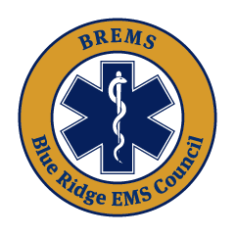
Valuable resources from one of our sister councils, ODEMSA: Regional Drug Box Program Updates, Agency Guidance, FAQs, and Resources – Old Dominion EMS Alliance, Inc. (odemsa.net)

On November 27, 2024, the regulations set forth by the U.S. Food and Drug Administration (FDA) will come into effect. We are actively collaborating with stakeholders, other Regional EMS Councils, the Virginia Office of EMS, and various entities to assess the potential impact of these FDA changes on the Drug Box Program for each council.

In the interim, it is strongly advised that EMS agencies in the Commonwealth take the necessary steps to acquire a Controlled Substances Registration (CSR) through the Department of Health Professions (DHP). It’s important to note that with over 600 EMS agencies statewide, delaying the acquisition of a CSR may delay the ability of an agency to purchase and/or store medications, which could impact the agency’s ability to participate in the regional drug box program.

